**PROJECT COVER**



**GROUP PROJECT**

**Lecturer :** [**Mr. Muhammad Arif Bin Hasan**](https://ebwise.mmu.edu.my/user/view.php?id=72713&course=5821)

**Group: LDCW 1C-G9**

*Prepared by:*

| **Student ID** | **Student Name** | **Phone number** |
| --- | --- | --- |
| 1221101418 | CHAN QING HANG | 01163681623 |
| 1211109967 | LEONG JIN SOON | 0166737277 |
| 1211109969 | LAW CHENG XIAN | 0176079827 |
| 1231301646 | TEE XIN QING | 01131813536 |
| 1231303127 | IGNATIUS NG WEI SIONG | 0187909711 |

**Declaration by group leader**

I hereby declare that all group members’ names are correctly included in the above section. I hold a copy of this assignment which I can produce if the original is lost or damaged. I certify that no part of this assignment has been copied from any other student’s work or from any other source except where due acknowledgement is made in the assignment.

Group leader’s signature : Mosess

Group leader’s name : CHAN QING HANG  
Group leader’s student ID : 1221101418

Date : 25/6/2024

**Group member declaration**

*(Each group member, including the* ***group leader****, must individually fill up and submit this form)*

Group member’s name : CHAN QING HANG

For the purpose of completing this assignment, I have performed the following tasks (please list):

First, I had held several project meetings to discuss the task distribution. As a leader, I communicated with my teammates and supervised their work. Secondly, I had completed the wix website and figma prototype design. Third, I had done the sitemap. Fourth, I did the documentation for our group report. Fifth, I record the video and edit our team presentation video. Lastly, I submit to our lecturer before the due date.

*I hereby declare that I have assessed this submission and I take full responsibility should there be any inaccuracies, incompleteness, omissions, delays or non-submission.*

Group member’s signature : Mosess

Group member’s name : CHAN QING HANG

Group member’s ID : 1221101418

Group member’s tel. no. : 011 6368 1623

Group member’s email : qinghang7@gmail.com

Date : 26/6/24

**Group member declaration**

*(Each group member, including the* ***group leader****, must individually fill up and submit this form)*

Group member’s name : LEONG JIN SOON

For the purpose of completing this assignment, I have performed the following tasks (please list):

I have done everything that the leader assigned us to do.

I have participated in all the meeting discussions with our group members.

I have done the Git & GitHub part.

I have converted figma to code such as html and css style.

*I hereby declare that I have assessed this submission and I take full responsibility should there be any inaccuracies, incompleteness, omissions, delays or non-submission.*

Group member’s signature : Leong

Group member’s name : LEONG JIN SOON

Group member’s ID : 1211109967

Group member’s tel. no. : 0166737277

Group member’s email : jsleong44@gmail.com

Date : 21/6/2024

**Group member declaration**

*(Each group member, including the* ***group leader****, must individually fill up and submit this form)*

Group member’s name : Law Cheng Xian

For the purpose of completing this assignment, I have performed the following tasks (please list):

I have done everything that the leader assigned us to do.

I have participated in all the meeting discussions with our group members.

I have done the Git & GitHub part.

I have converted figma to code such as html and css style.

*I hereby declare that I have assessed this submission and I take full responsibility should there be any inaccuracies, incompleteness, omissions, delays or non-submission.*

Group member’s signature : LAW

Group member’s name : Law Cheng Xian

Group member’s ID : 1211109969

Group member’s tel. no. : 0176079827

Group member’s email : lawchengxians@gmail.com

Date : 25/6/2024

**Group member declaration**

*(Each group member, including the* ***group leader****, must individually fill up and submit this form)*

Group member’s name : TEE XIN QING

For the purpose of completing this assignment, I have performed the following tasks (please list):

1. I have done everything that the leader assigned us to do.
2. I have participated in all the meeting discussions with our group members.
3. I have done the mobile apps user manual.

*I hereby declare that I have assessed this submission and I take full responsibility should there be any inaccuracies, incompleteness, omissions, delays or non-submission.*

Group member’s signature : TEE

Group member’s name : TEE XIN QING

Group member’s ID : 1231301646

Group member’s tel. no. : 01131813536

Group member’s email : 1231301646@student.mmu.edu.my

Date : 26/6/2024

**Group member declaration**

*(Each group member, including the* ***group leader****, must individually fill up and submit this form)*

Group member’s name : IGNATIUS NG WEI SIONG

For the purpose of completing this assignment, I have performed the following tasks (please list):

1. I have done everything that the leader assigned us to do.
2. I have participated in all the meeting discussions with our group members.
3. I have done the Figma ( **mobile apps prototype**).
4. I have done the **Introduction**.

*I hereby declare that I have assessed this submission and I take full responsibility should there be any inaccuracies, incompleteness, omissions, delays or non-submission.*

Group member’s signature : 

Group member’s name : IGNATIUS NG WEI SIONG

Group member’s ID : 1231303127

Group member’s tel. no. : 0187909711

Group member’s email : [1231303127@student.mmu.edu.my](mailto:1231303127@student.mmu.edu.my)

Date : 26 June 2024

**CONTENT PAGE NO.**

1. INTRODUCTION

2. SITE MAP

3. WEBSITE URL LINK

4. MOBILE APPS URL LINK (FIGMA)

5. MOBILE APPS USER MANUAL

6. GIT & GITHUB COLLABORATION

7. PRESENTATION VIDEO LINK

1. **INTRODUCTION**

In this project, our team chose the project type of E-commerce. We are an emerging technology startup company that focuses on providing high-quality Bluetooth mice for gamers. Our company's mission is to allow our customers to freely design and customize their own exclusive Bluetooth mice. Our company's brand name is "Poppy Gaming Mouse". The name "Poppy" represents our company's commitment to stand out in the vast technology market through innovative products and excellent customer service. At the same time, our company hopes to provide a better user experience for mouse users.

Our company provides users with a website for online sales of Bluetooth mice. Our website provides users with high-quality images of Bluetooth mice to let users know more about our products. At the same time, we list all our Bluetooth mouse products on the website and add the add to cart function for users.

Our website also opens a wish list for users to add their favorite products to the list. After the customer successfully places an order and successfully pays, they will receive an order invoice. They can also track the shipping status through the website.

We also used Figma to make a prototype of Mobile apps. We added the function of customized products to the mobile apps prototype, which means that our customers can customize their mice. Next, we also used Canva to create a user manual to guide customers in using our Mobile apps.

1. **SITE MAP**

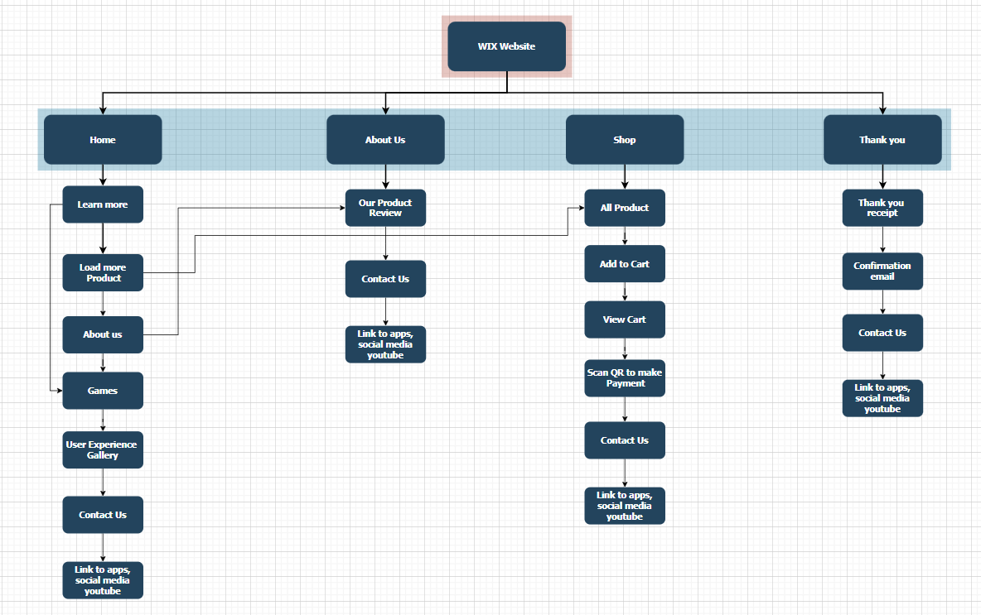  
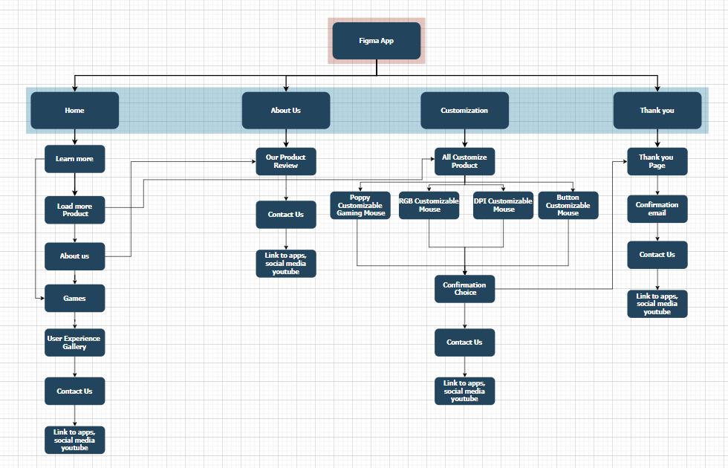

3. **WEBSITE URL LINK**    
Link: <https://qinghang7.wixsite.com/poppy-gaming-mouse-1>  
  
Homepage of our wix website:

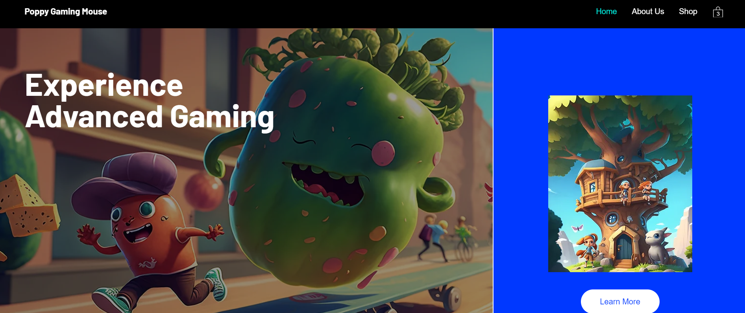

You can change to mobile version to visit our website.  
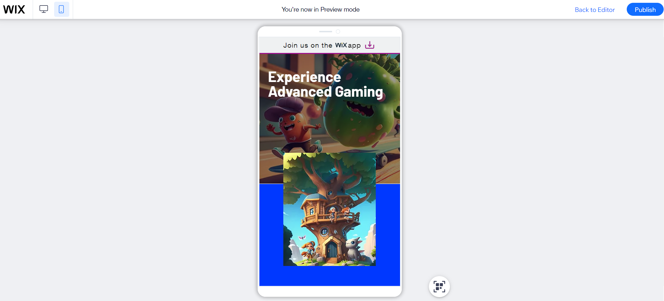  
After selecting the product you want, you can add to cart

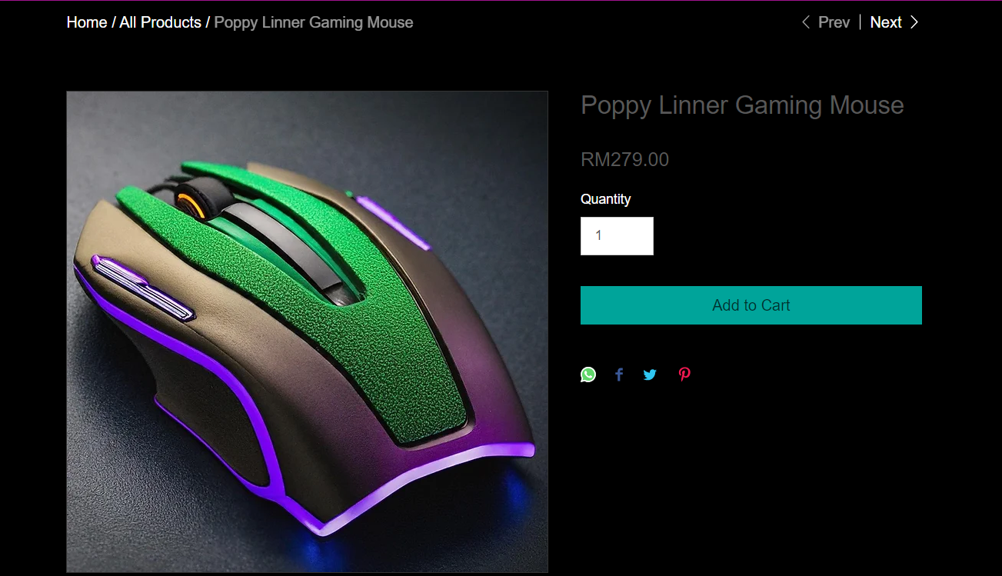

Please scan the QR code to purchase the Item.  
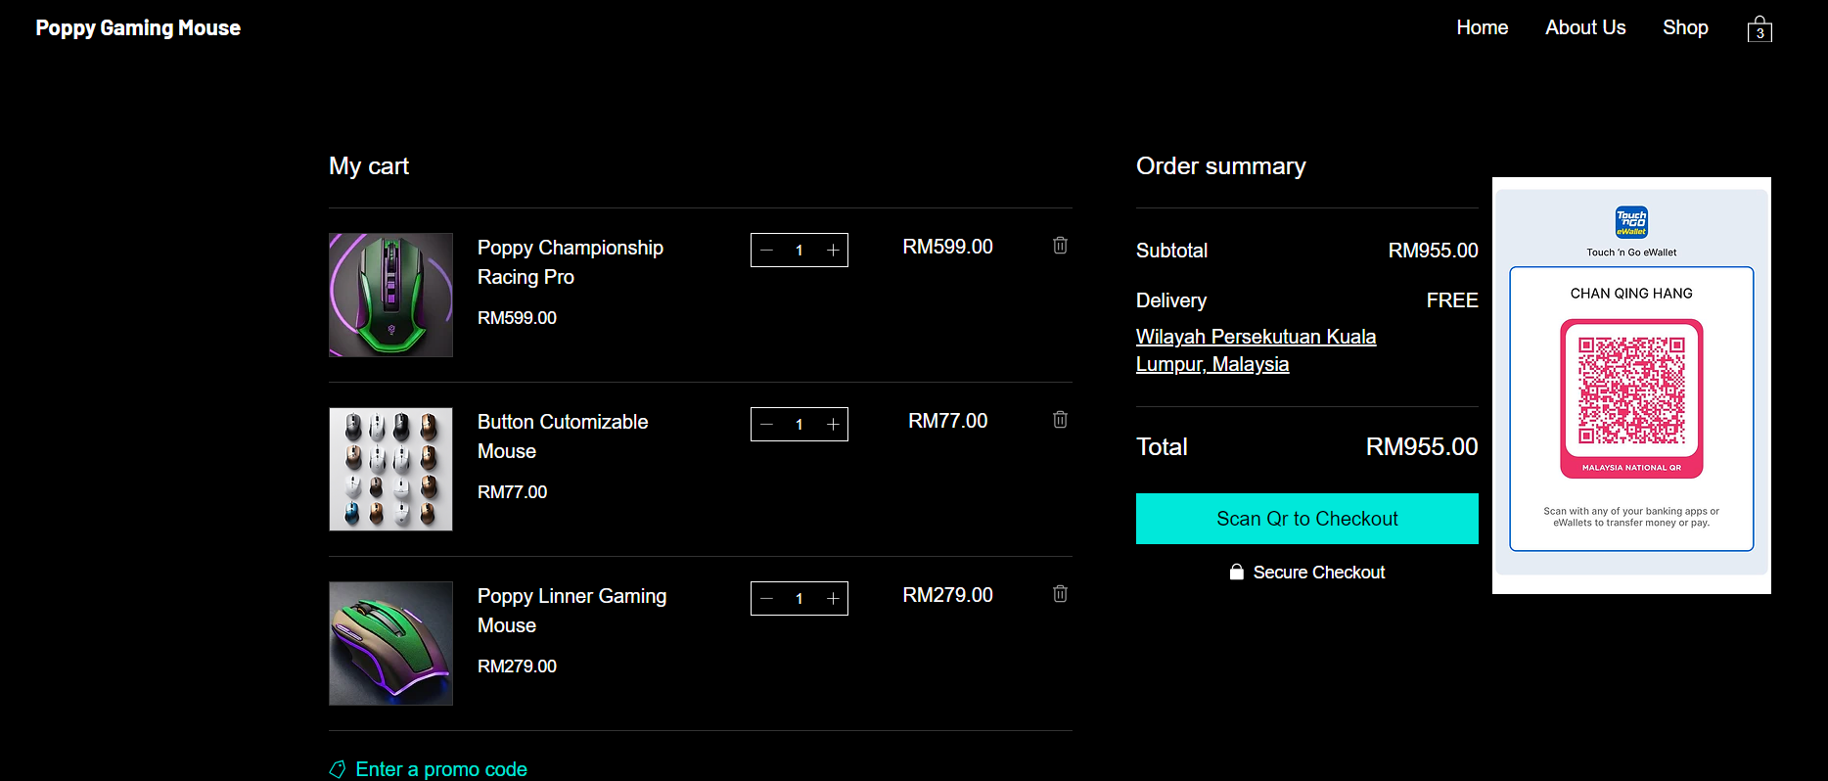  
  
This is our Thank You page, after payment, you will receive a thank you receipt and confirmation email.  
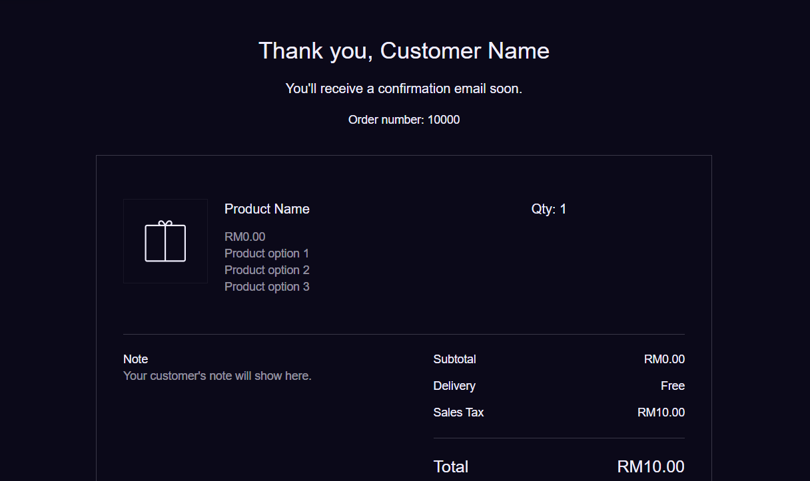  
  
Lastly, you can visit our social media by clicking the Instagram link, visit our youtube channel. You also can start customising your product after you make the payment by clicking the “phone button”.  
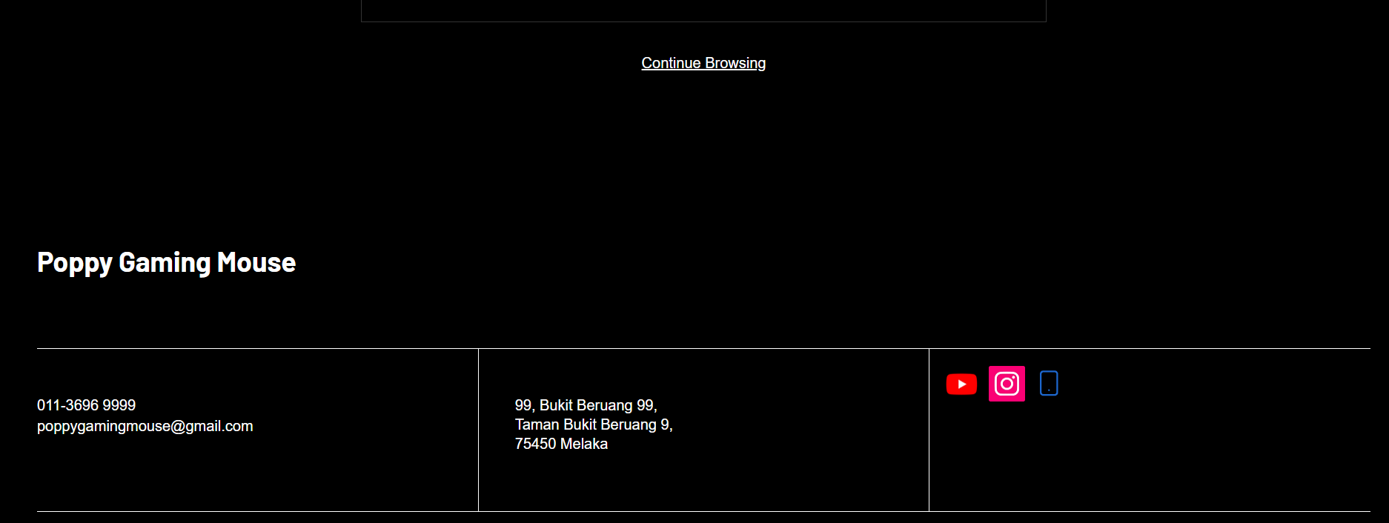

4. **MOBILE APPS URL LINK (FIGMA)**    
Link: <https://www.figma.com/design/N479fq6BqDqwMvSZXgkh8m/Untitled?t=SnZmbeStZn2fZt2L-1>

Overall figma Prototype design:

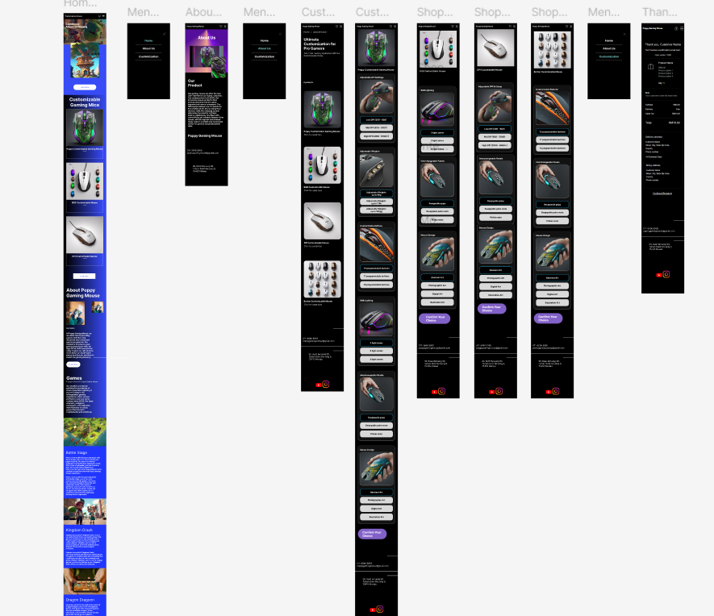

Homepage of the figma app:

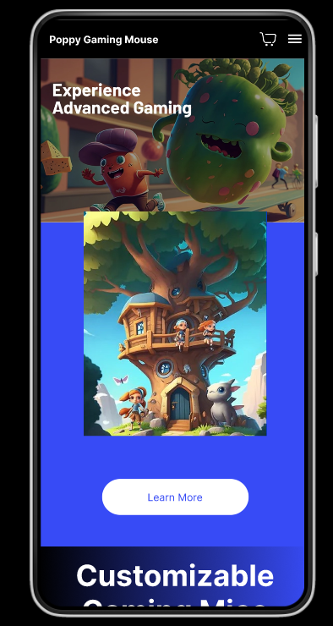

Select customization to customise your preference mouse

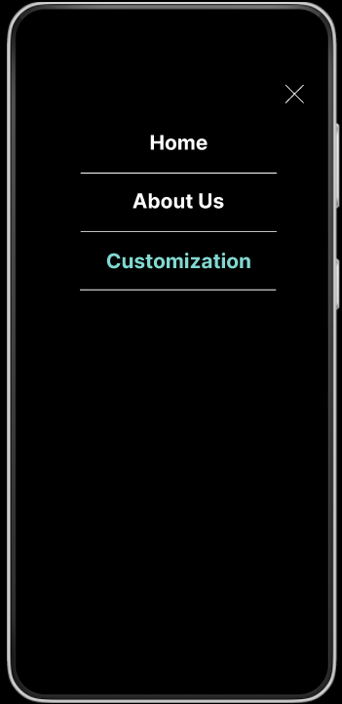

Please select your choice and Press “Confirm Your Choice”  
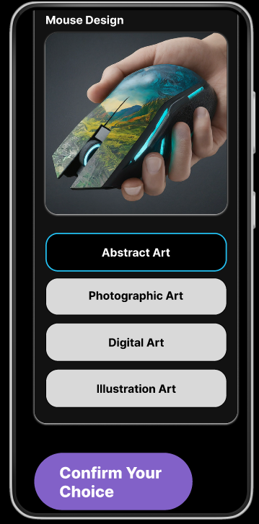

You will receive your gaming mouse after you have customised it. You will receive a confirmation email also to confirm your selection.

5.  **MOBILE APPS USER MANUAL**

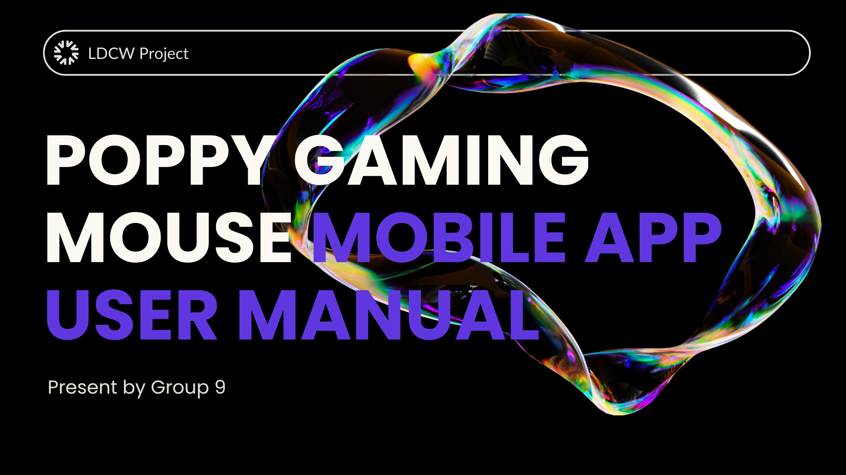

Cover page of Poppy Gaming Mouse Mobile App User Manual.

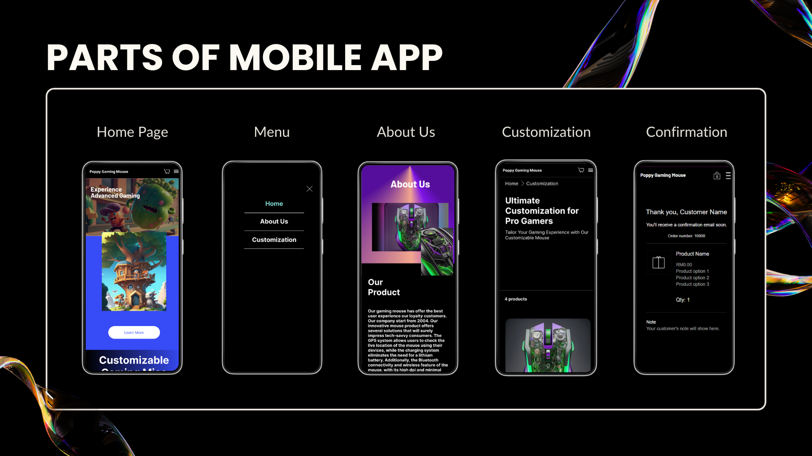

Introduction of main parts of the Poppy Gaming Mouse mobile app which is Home Page, Menu, About Us, Customization and Confirmation page.

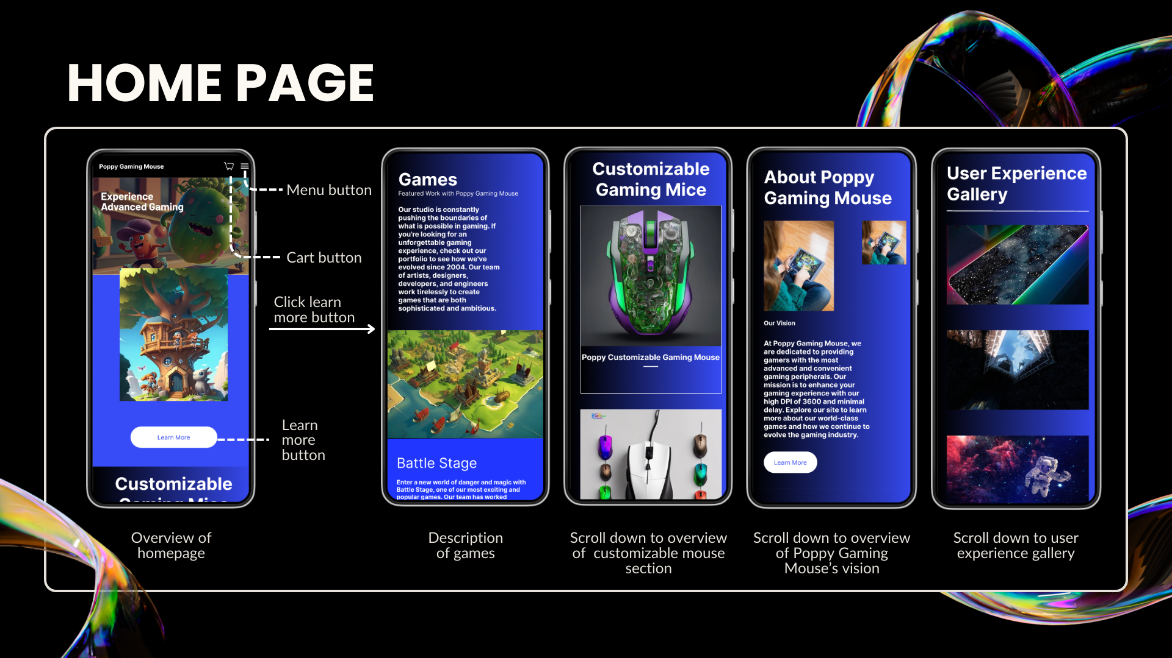

The Home Page is the main screen when the user opens the Poppy Gaming Mobile App. It shows an overview of the app’s main features and serves as the starting point for navigating the app. There is a cart button and a menu button(3 horizontal lines) on the upper right side of the home page and a learn more button on the bottom. When the user taps the learn more button, it will scroll down directly to the games introduction section. When the user scrolls down through the home page, it shows some customizable gaming mice, the vision of Poppy Gaming Mouse, an introduction to Games, the User Experience Gallery, and the Company’s contacts and social media.

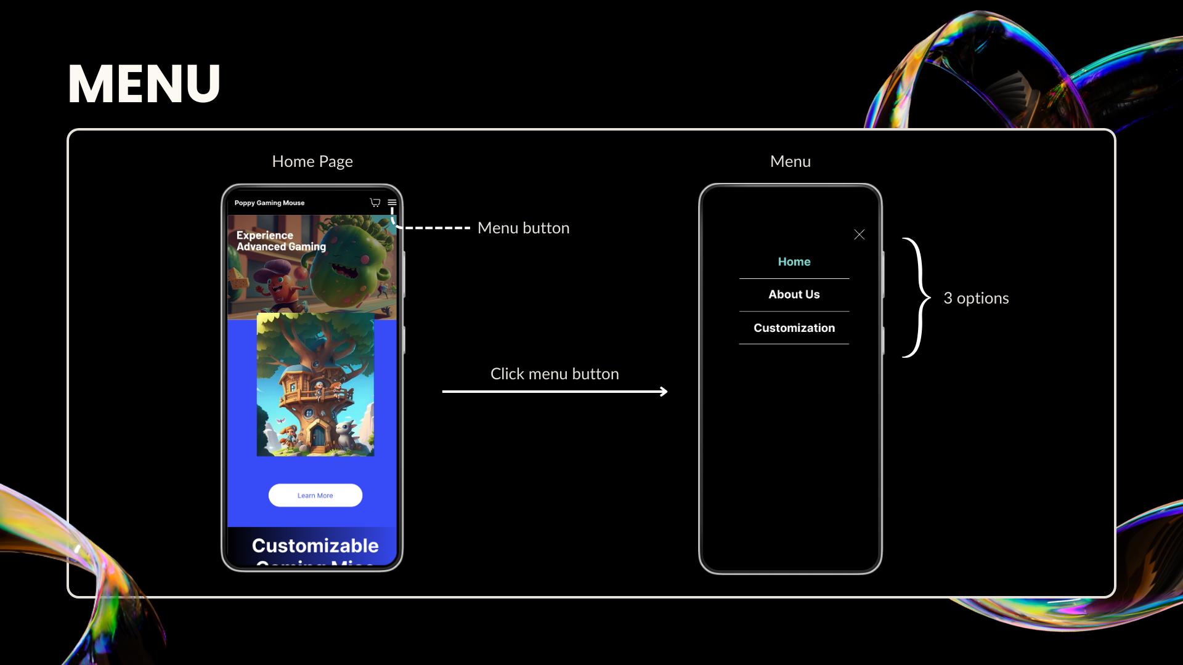

When the user taps on the menu icon on the upper right side of the home page, it expands to show all sections available in the app. There are 3 options which are:

1. Home: Returns the user to the homepage.
2. About Us: Information about the product and the company behind it.
3. Customization: This takes the user to the section where they can customize their own mouse.

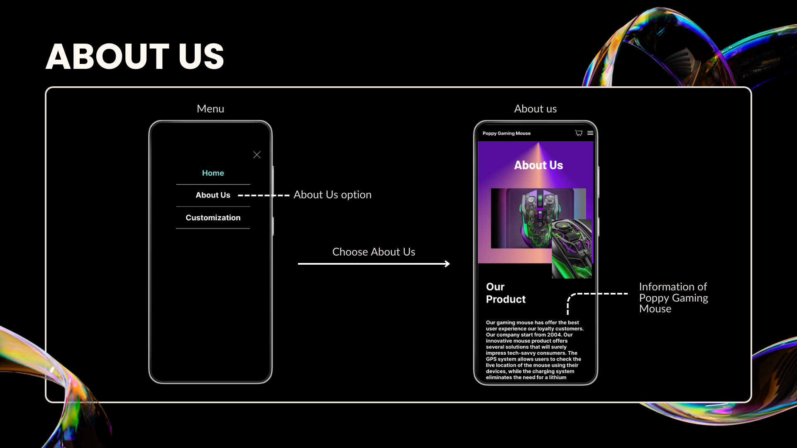

The “About Us” section presents information about the Poppy Gaming Mouse Mobile App and its developers. This section typically explains a brief history of the company, its mission, and a description of the product quality and innovation. There is also company’s contact and address below.

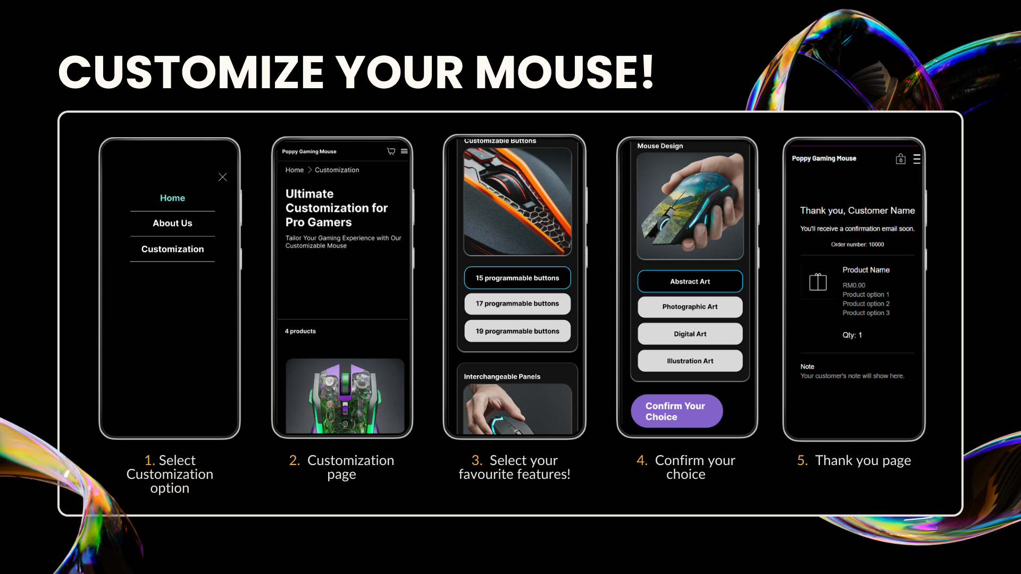

The customization section is where the user can customize their gaming mouse to suit their preferences. First, the user chooses the customization option from the menu. Then, the user can choose the customizable mouse product, and choose their preferred features for the mouse including DPI settings, weights, buttons, RGB Lighting, interchangeable panels, and mouse design. After that, click the button “Confirm Your Choice” and the Thank You page appear.

6. **GIT & GITHUB COLLABORATION**

1. **git init**

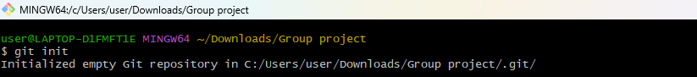

1. **git status**

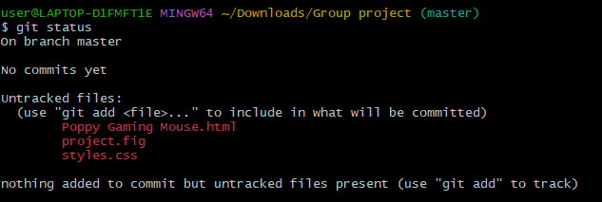

1. **git commit**

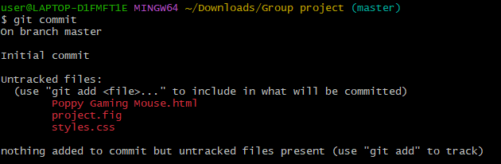

1. **git add “Poppy Gaming Mouse.html”**



1. **git add “project.fig”**



1. **git add “styles.css”**



1. **git status**

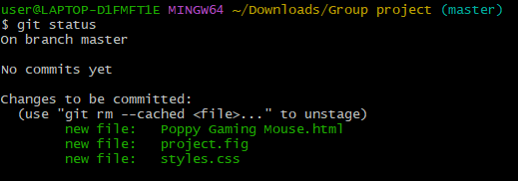

1. **git commit -m “commit project items”**

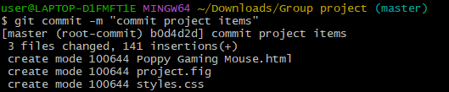

1. **git remote add origin https://github.com/Characters88/LDCW-6123-1C-G9.git**



1. **git remote**



1. **git push origin master**

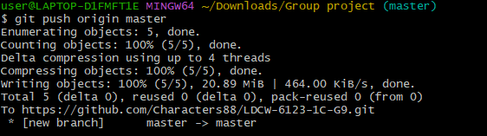

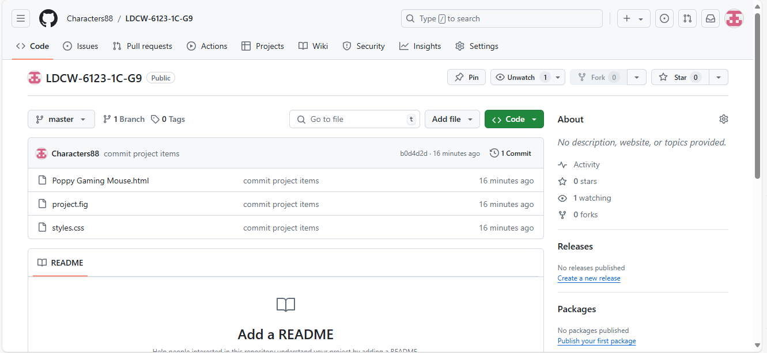

1. **git status**

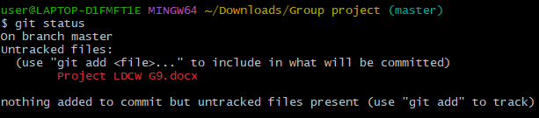

1. **git add “Project LDCW G9.docx”**



1. **git commit -m “upload project docs”**

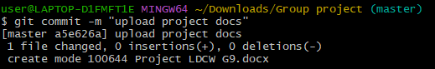

1. **git push origin master**

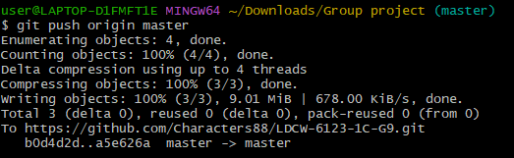

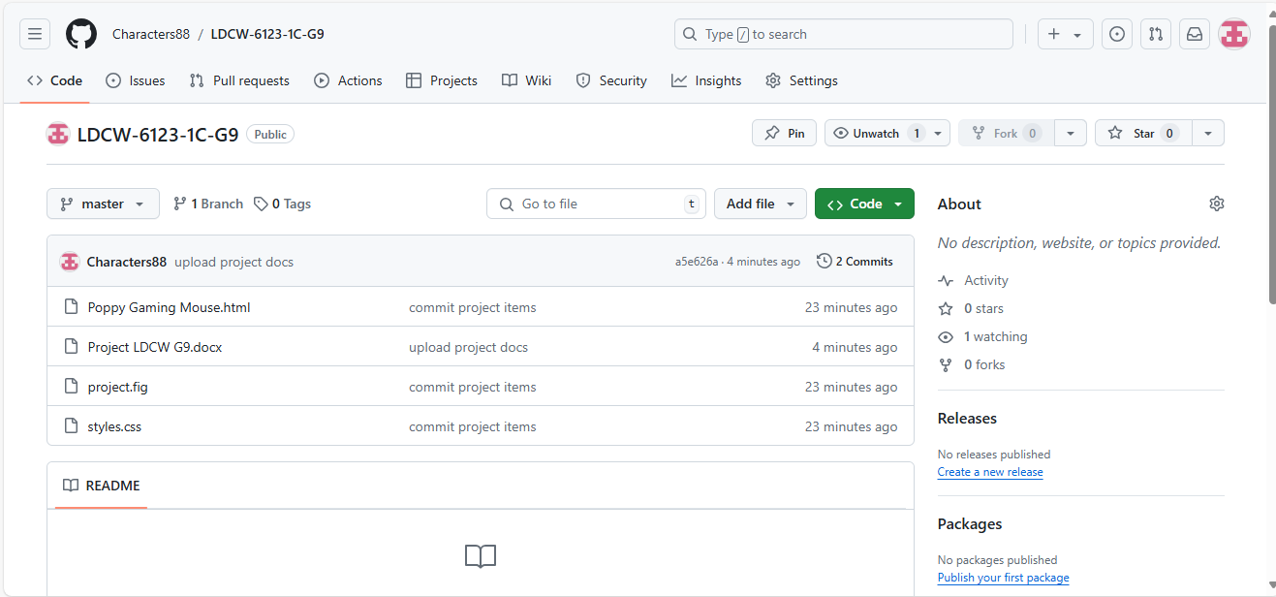

1. **git log**

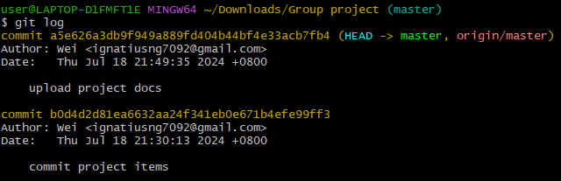

**Git Log**

1. commit a5e626a3db9f949a889fd404b44bf4e33acb7fb4 (HEAD -> master, origin/master)

Author: Wei <ignatiusng7092@gmail.com>

Date: Thu Jul 18 21:49:35 2024 +0800

upload project docs

1. commit b0d4d2d81ea6632aa24f341eb0e671b4efe99ff3

Author: Wei <ignatiusng7092@gmail.com>

Date: Thu Jul 18 21:30:13 2024 +0800

commit project items

7. **PRESENTATION VIDEO LINK**

Youtube Link: <https://youtu.be/yjCfSm9QygA>

